Git commands

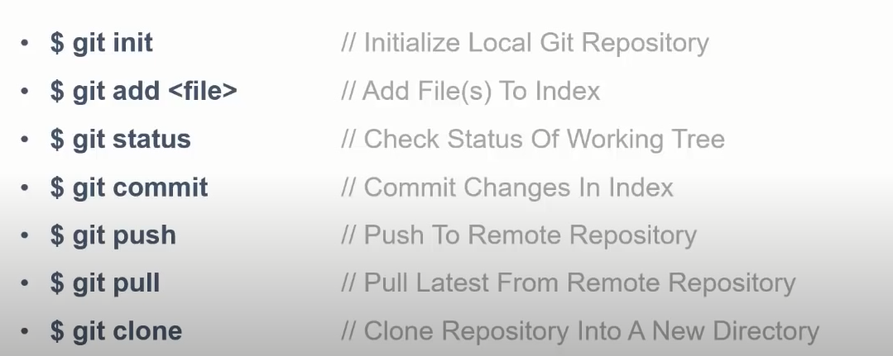

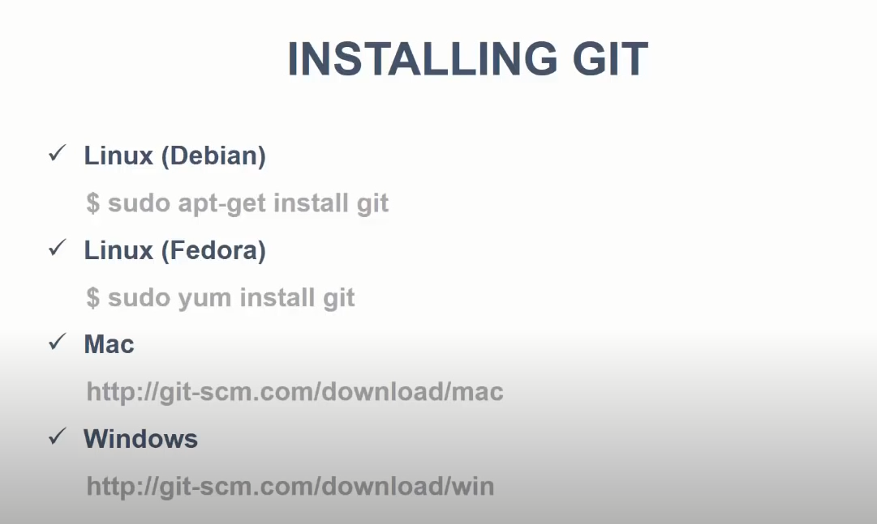

1. Create a directory
2. Right click and click git bash here
3. Type Touch app.js

That command create a file app.js in the same directory

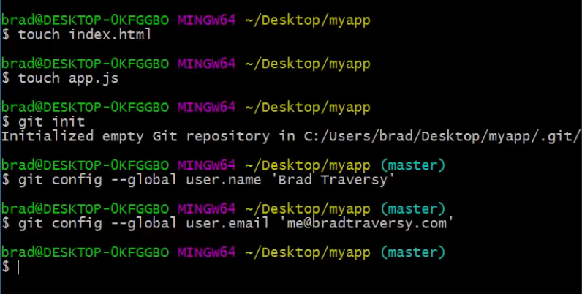

git config –global user.name ‘susanmathew2022’

git config –global user.email ‘susanmathew2022@gmail.com’

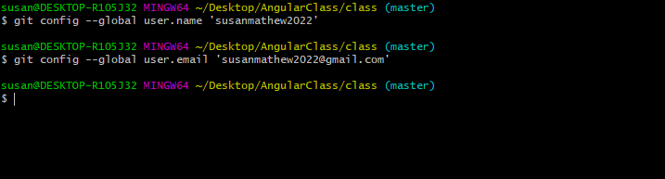

To remove index.html file



Add every thing

Git add .

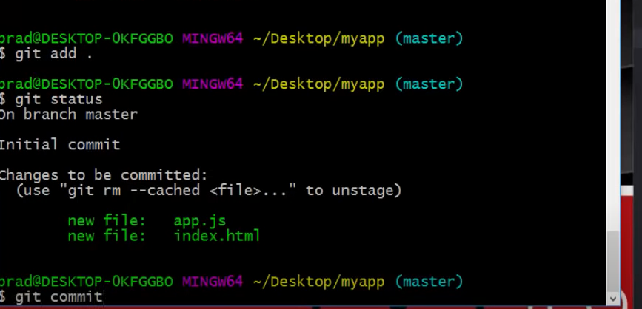

Git commit opens a new window, where you can add your comment by pressing” i” insert key.

The type :wq to exit out

Instead of doing this you canput a comment next to commit

Git commit -m ‘changed app.js’

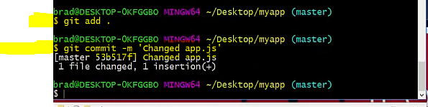

(use "git add <file>..." to update what will be committed)

(use "git restore <file>..." to discard changes in working directory

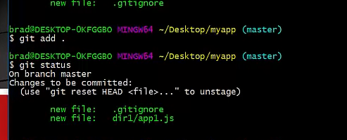

Branching git repository

Create new branch



Checkout new branch

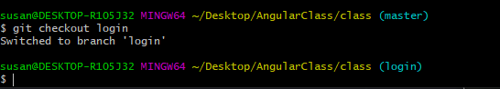

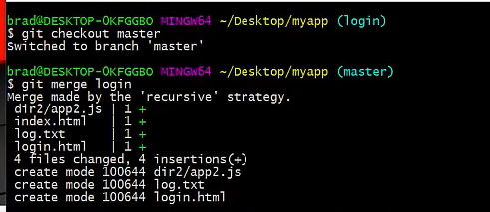

Git checkout master

To go back to master

Git merge login

To merge login with master

git init

git add README.md

git commit -m "first commit"

git branch -M main

git remote add origin https://github.com/susanmathew2022/MyFirstProject.git

git push -u origin main

git remote add origin <https://github.com/susanmathew2022/MyFirstProject.git>

Add or Update a file and Push

git add .

git commit -m "readme"

git push -u origin main

git push

git push --set--upstream origin master

| **BRANCHES.** |  |  |
| --- | --- | --- |
| **git branch** | List all local branches. |  |
| **git branch -a** | List remote and local branches. |  |
| **git checkout -b branch_name** | Create a local branch and switch to it. |  |
| **git checkout branch_name** | Switch to an existing branch. |  |
| **git push origin branch_name** | Push branch to remote. |  |
| **git branch -m new_name** | Rename current branch. |  |
| **git branch -d branch_name** | Delete a local branch. |  |
| **git push origin :branch_name** | Delete a remote branch. |  |
| **LOGS.** |  |  |
| **git log --oneline** | Show commit history in single lines. |  |
| **git log -2** | Show commit history for last N commits. |  |
| **git log -p -2** | Show commit history for last N commits with diff. |  |
| **git diff** | Show all local file changes in the working tree. |  |
| **git diff myfile** | Show changes made to a file. |  |
| **git blame myfile** | Show who changed what & when in a file. |  |
| **git remote show origin** | Show remote branches and their mapping to local. |  |
| **CLEANUP.** |  |  |
| **git clean -f** | Delete all untracked files. |  |
| **git clean -df** | Delete all untracked files and directories. |  |
| **git checkout -- .** | Undo local modifications to all files. |  |
| **git reset HEAD myfile** | Unstage a file. |  |
| **TAGS.** |  |  |
| **git pull --tags** | Get remote tags. |  |
| **git checkout tag_name** | Switch to an existing tag. |  |
| **git tag** | List all tags. |  |
| **git tag -a tag_name -m "tag message"** | Create a new tag. |  |
| **git push --tags** | Push all tags to remote repo. |  |
| **STASHES.** |  |  |
| **git stash save "stash name" && git stash** | Save changes to a stash. |  |
| **git stash list** | List all stashes. |  |
| **git stash pop** | Apply a stash and delete it from stash list. |  |

git push --set--upstream origin master

try this if you cant push after an update

<https://www.youtube.com/watch?v=F2DBSH2VoHQ>

<https://gitsheet.wtf/>

git push origin master

Unanswered q uestions

ssh

<https://www.youtube.com/watch?v=WZQc7RUAg18uestions>

<https://www.youtube.com/watch?v=NCwa_xi0Uuc>